AI Recommended Retest Report
Retest Recovery Analysis & Policy Recommendation
Source: Retest log.csv (16,423 retested fail events) | Prepared: August 12, 2026

1. Executive Summary — AI Recommendation
16,423 initially-failing test events were retested. 5,389 (32.8%) passed on retest and were disposed PASS; 11,034 (67.2%) failed again and were scrapped. Recovery rate is driven almost entirely by the labeled failure scenario, not by which test parameter or site was involved — the same four-scenario ranking holds consistently across all four test parameters (HOLD_SLACK_PS, IR_DROP_MV, SETUP_SLACK_PS, THERMAL_C) and all four sites.
Recommendation: Treat retest policy by scenario, not uniformly. Borderline Failure (42.1% recovery, largest volume) is the strongest signal of an overly tight guardband and merits a limit-definition review. Severe Failure (10.9% recovery) rarely benefits from retest — consider routing straight to scrap to save test time. Tester Related and Temperature Effect failures sit in between and support continuing retest while investigating handler/thermal settling causes.

2. Methodology
Every row in the source log represents one retested failing test event, with initial_result=FAIL and retest_performed=YES for all 16,423 rows. Each event carries a scenario_type label (Borderline Failure, Tester Related Failure, Temperature Effect, Severe Failure), a test_name/parameter, tester and site identifiers, lot/wafer/die coordinates, and the measured value against its limit. Recovery rate is computed as the share of events whose final_disposition is PASS (i.e., retest_result flipped FAIL to PASS) versus SCRAP (sustained FAIL).

3. Recovery Ranking by Failure Scenario
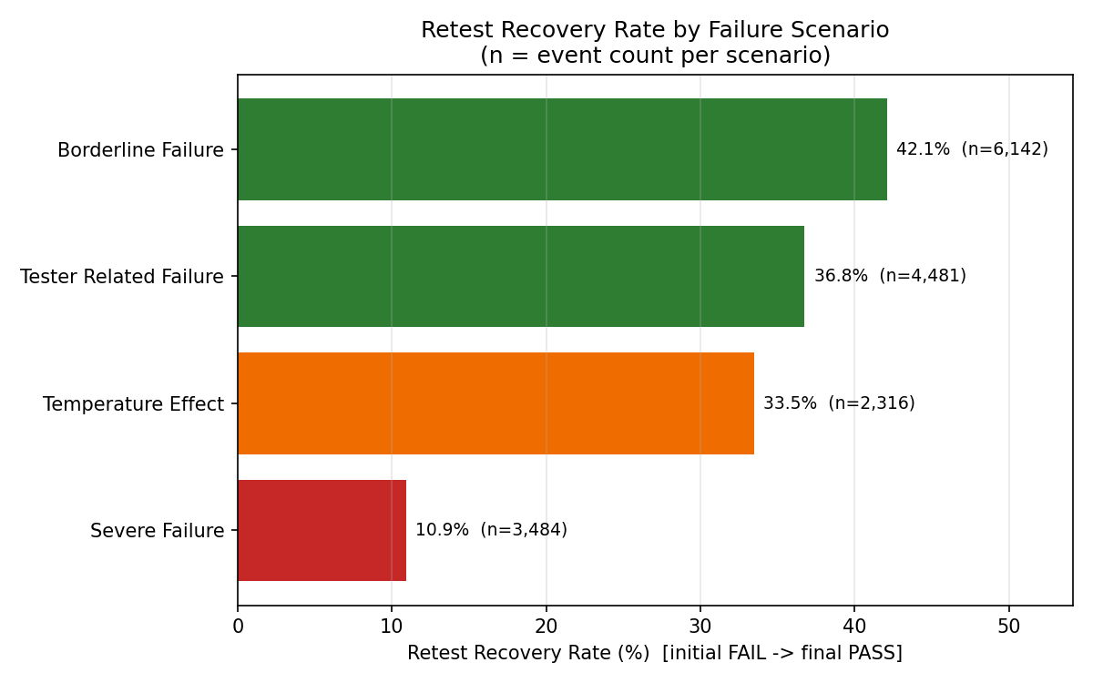
Scenario | Events | Recovered | Recovery Rate | Recommendation
Borderline Failure | 6,142 | 2,587 | 42.1% | Strongest retest candidate — margin/guardband likely too tight; review limit definitions
Tester Related Failure | 4,481 | 1,647 | 36.8% | Retest recovers over a third — supports retest-and-monitor; validate against tester/handler variation once multi-tester data is available
Temperature Effect | 2,316 | 775 | 33.5% | Moderate recovery — review thermal soak time / settling before final test
Severe Failure | 3,484 | 380 | 10.9% | Retest rarely recovers — real defects; consider skipping retest for this bin to save test time

4. Recovery by Test Parameter
Recovery rate is fairly uniform across the four measured parameters (30.6-35.3%), confirming that the scenario label — not the specific test — is the primary driver of retest recoverability.
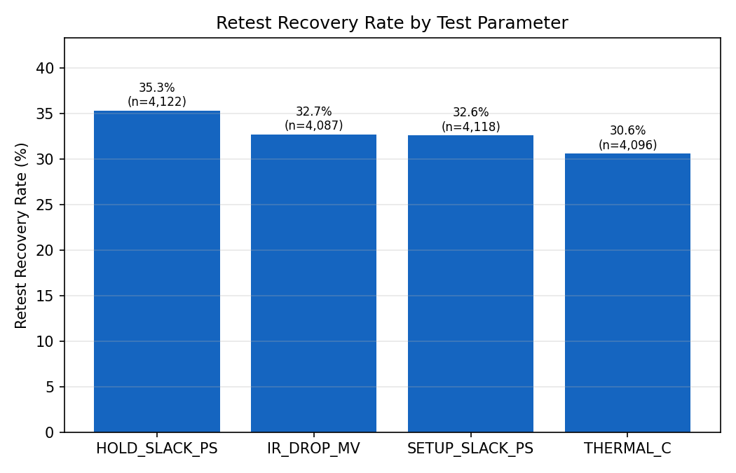
Test Parameter | Events | Recovered | Recovery Rate
HOLD_SLACK_PS | 4,122 | 1,456 | 35.3%
IR_DROP_MV | 4,087 | 1,337 | 32.7%
SETUP_SLACK_PS | 4,118 | 1,343 | 32.6%
THERMAL_C | 4,096 | 1,253 | 30.6%

5. Site & Data Quality Notes
- Site-level recovery rate ranges narrowly from 31.4% (Site 4) to 35.2% (Site 2) — not a major independent driver once scenario_type is accounted for.
- All 16,423 events were tested on a single tester ID (TESTER_A). The 'Tester Related Failure' label could not be independently validated against a second tester in this dataset — confirm with multi-tester data before acting on it as a tester-specific finding.
- Limit provenance is roughly split: 8,183 events (49.8%) use SOURCE_CONFIRMED limits, and 8,240 (50.2%) use DERIVED_PROXY_NOT_SOURCE_LIMIT limits (not sourced from the official spec). Recovery rates are close between the two (31.7% vs 34.0%), but retest decisions on proxy-limit events carry more uncertainty.
- Several fields in the source file are explicitly flagged SYNTHETIC_ASSUMED / DERIVED_PROTOTYPE_ONLY / REQUIRES_TEMPORAL_VALIDATION, indicating parts of this dataset are modeled/prototype data rather than fully confirmed production measurements.

6. Caveats
This analysis reflects the scenario labels as provided in the source log; it does not independently re-derive failure classification from raw measurements. Two lots (DTL_DRIFT_006 and DTL_LOOSE_003) account for 95.5% of all events, so findings are weighted heavily toward whatever conditions those two lots represent. Recommendations should be validated against a broader, multi-tester, multi-lot sample before changing production retest or guardband policy.

